**Pizza Sales**

**KPI’s:**

1. **Total Revenue:**

SELECT

SUM(total_price) AS Total_Revenue

FROM

pizza_sales

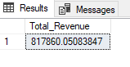

**2.Average Order Value:**

SELECT

SUM(total_price) / COUNT(DISTINCT order_id) AS Avg_Order_value

FROM

pizza_sales

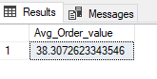

**3. Total_Pizza_Sales:**

SELECT

SUM(quantity) AS Total_Pizza_Sales

FROM

pizza_sales

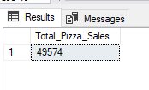

**4. Total Orders:**

SELECT

COUNT(DISTINCT order_id) AS Total_Orders

FROM

pizza_sales

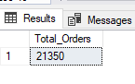

**5. Average Pizzas per Order :**

SELECT

CAST(SUM(quantity) AS DECIMAL(10,2)) / CAST(COUNT(DISTINCT order_id) AS DECIMAL(10,2)) AS Average_Pizzas_Per_Order

FROM

pizza_sales

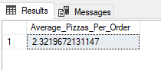

**6.Hourly Trend for Total Pizzas Sold:**

SELECT

DATEPART(HOUR, order_time) AS Order_Hour,

SUM(quantity) AS Total_Pizza_Sales

FROM

pizza_sales

GROUP BY DATEPART(HOUR, order_time)

ORDER BY DATEPART(HOUR, order_time)

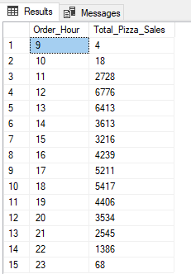

**7.Weekly Trend for Total Orders:**

SELECT

DATEPART(ISO_WEEK, order_date) AS Week_Number,

YEAR(order_date) AS Order_Year,

COUNT(DISTINCT order_id) AS Total_Orders

FROM

pizza_sales

GROUP BY DATEPART(ISO_WEEK, order_date),YEAR(order_date)

ORDER BY DATEPART(ISO_WEEK, order_date),YEAR(order_date)

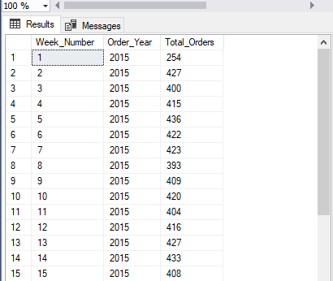

**8.Percentage of Total Sales of Pizza category:**

SELECT

pizza_category, SUM(total_price) * 100 / (SELECT SUM(total_price) FROM pizza_sales) AS PCT

FROM

pizza_sales

GROUP BY pizza_category

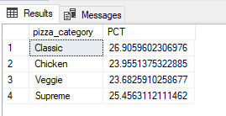

**9.Percentage of Sales by Pizza Size:**

SELECT

pizza_size, SUM(total_price) * 100 / (SELECT SUM(total_price) FROM pizza_sales) AS PCT

FROM

pizza_sales

GROUP BY pizza_size

ORDER BY PCT

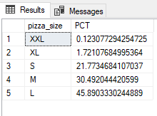

**10.Total pizzas sold by Pizza Category:**

SELECT

pizza_category,

SUM(quantity) AS Total_PizzaSales_Category

FROM

pizza_sales

GROUP BY pizza_category

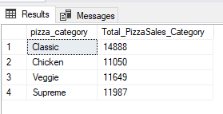

**11.Top 5 Best Sellers by Total Pizza Sold:**

SELECT

TOP 5

pizza_name,

SUM(total_price) AS Total_Revenue

FROM

pizza_sales

GROUP BY pizza_name

ORDER BY Total_Revenue DESC

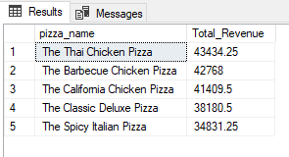

**12.Bottom 5 Worst Sellers by Total Pizzas Sold:**

SELECT

TOP 5

pizza_name,

SUM(total_price) AS Total_Revenue

FROM

pizza_sales

GROUP BY pizza_name

ORDER BY Total_Revenue

